Martin Dimo
05/05/2022
ME360 Product Design

Skateboard Deck Design

Objective
The goal of this project is to build the lightest skateboard deck given maximum stress and a factor of safety of 3. All freedom was given to the designer when it came to the shape, size, and style of the skateboard deck, meaning a certain amount of intuition was involved. The main steps are as follows:
- Preliminary design
- Material selection
- Finite element analysis
- Weight optimization
By creating an objective for each step, the final design will fulfill all constraints while preserving its originality.

Constraints
The constraints on the design were fairly limited in this project. Given the information on skateboards over history, they don’t tend to vary too much in size. Given the fact that the load is going to be applied over the surface area of two feet of the US size 12, the board needs to be big enough to comfortably fit that surface area. With a load of 180 pounds, the board is going to need to be strong enough to have a maximum displacement of 0.375 inches. This means that a material will need to be selected that satisfies that constraint, as well as perform within a safety factor of 3. The deck will still need to be a reasonable thickness and overall shape to classify as a skateboard and be recognizable enough to be an achievable design.

Context
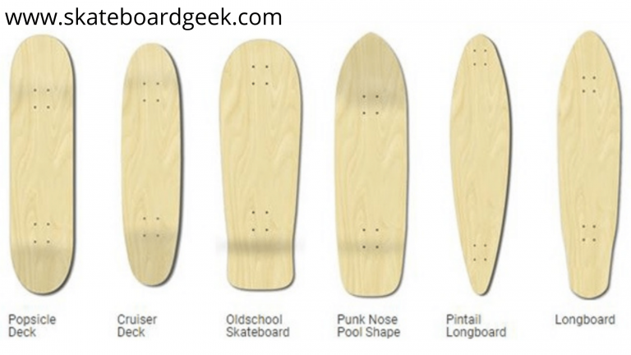
Skateboarding became popularized in California in the 1950s and has swept the world as a staple of youth, activity, and extreme sports. Since its inception, skateboarding has broadened into many subcategories. The most famous and longest-existing variation is the trick skateboard, which is also referred to as the popsicle deck. Other shapes can be seen in the figure below.

Figure 1. Different deck shapes

The difference between the shapes of skateboards has physical implications in the way the skateboard flexes, turns, and performs overall. Longboards are usually for more casual, recreational riding, while popsicle decks are more rigid and responsive, making them effective in skateparks and ramps. The wheel and trucks also vary with skateboard style, but that is out of the scope of this project.

Design Decisions
To design a deck that successfully abides by the constraints, various factors need to be considered. First is the shape, which would influence how spread out the force acting on the deck would be. From experience, I chose to go with a popsicle deck design, given that they are designed to be the most rigid. In the real world, factors such as materials have impacted my experience (when I’ve ridden longboards, they have always been more flexible than trick skateboards), yet for this introductory project and being far from a skateboarding expert, I decided to stick with trends that already exist in the real-world market. This means I had to choose a size that would correspond well with a trick skateboard shape and the inflection of the board itself.
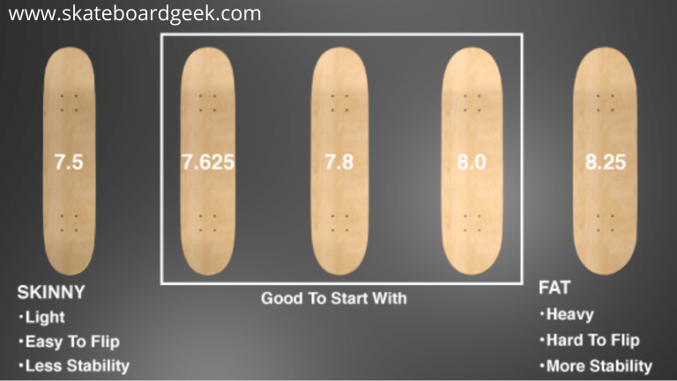

Figure 2. Skateboard widths based on various parameters
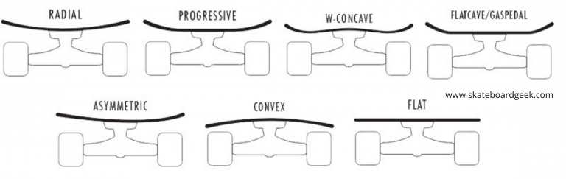

Figure 3. Skateboard inflection profiles

Model Application
Upon deciding on the shape and size, a rough sketch of the trick skateboard deck was drawn and dimensioned in Solidworks. Looking forward to when FEA will be applied, I also dimensioned a pair of US size 12 shoes onto the skateboard deck by overlaying a stock image and using a spline to outline the surface area of the deck that experiences the force due to the person standing on it.
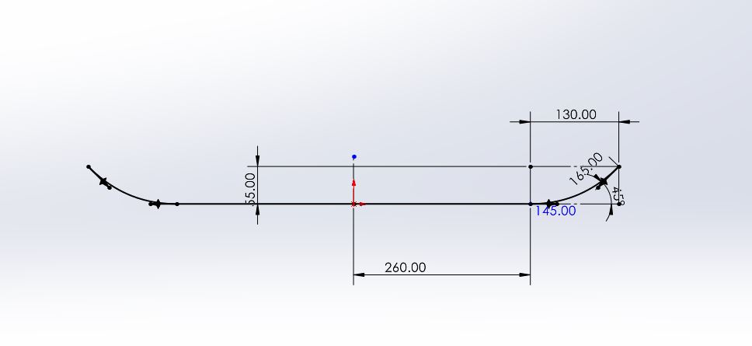

Figure 4. Solidworks sketch

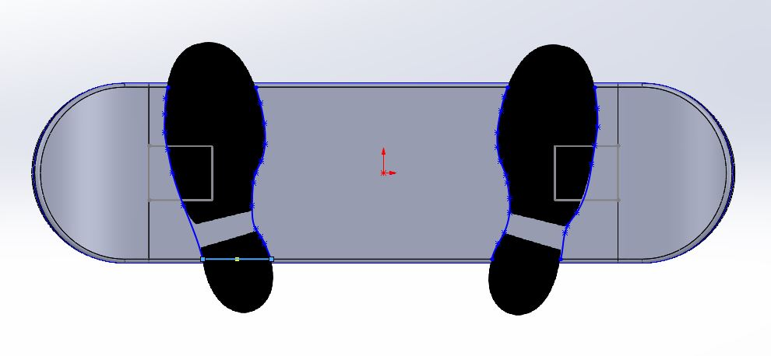

Figure 5. Shoe surface area overlay

The greyed-out boxes that intersect the images of the shoes depict the location of the trucks of the skateboard, which translates to the locations of joints in this FEA analysis. For realistic conditions, I placed the shoes partially over the trucks, as a rider in the real world does not place their feet directly over the trucks at all times while skateboarding. The model needed to be as realistic as possible in terms of usage to get accurate stress and displacement results.

Material Selection
Skateboard decks are made of various different kinds of wood. They typically have cross-pattern layers of lightweight woods such as balsa or maple, giving the deck more rigidity and strength. However, for this analysis, we are assuming that the deck is constructed of a solid, isotropic material. This already causes some error due to the fact that woods are considered anisotropic materials, meaning that they have varying strengths when stressed along different axes. Three different materials were considered; American Red Maple Wood, high-density Polyethylene, and 6061 Aluminum Alloy. Wood was selected since it was the most common real-world material in trick skateboards, while Polyethylene can be found in smaller size boards such as Penny boards (American brand of “cruiser” boards). 6061 Aluminum was tested due to its ubiquity and diverse usage as an affordable metal.

Finite Element Analysis
Three studies were conducted in Solidworks, with each one containing the same skateboard deck with the three specific materials applied. One of the boxes on the underside of the skateboard received a fixed joint, with the other being attached to a sliding/rolling joint. Additionally, a medium-complexity mesh was created for each, and a force of 400.3 N was applied to each surface of each shoe. (180lbf = 800.6 N)

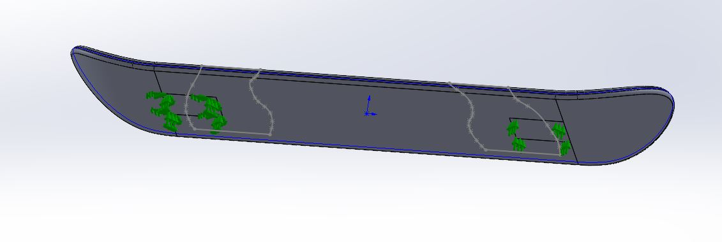

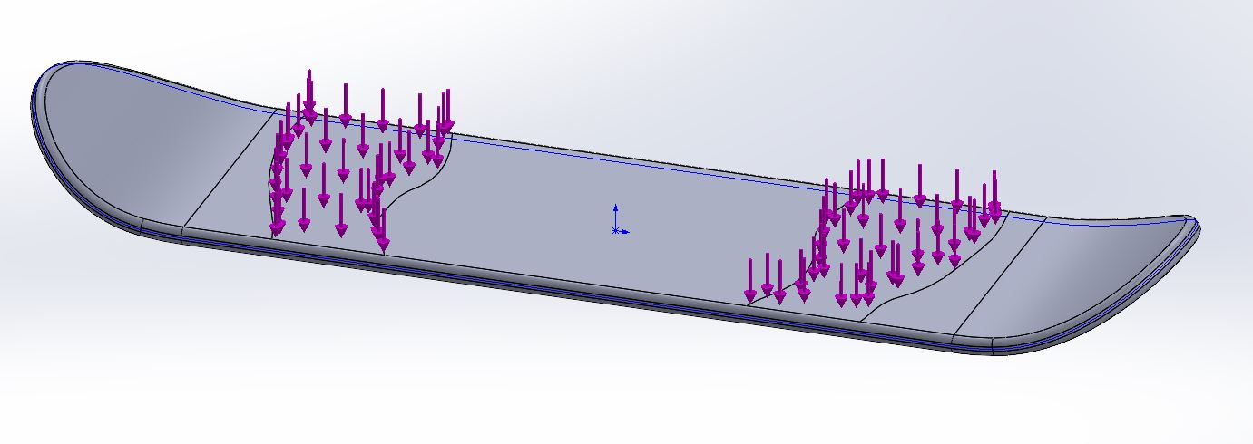

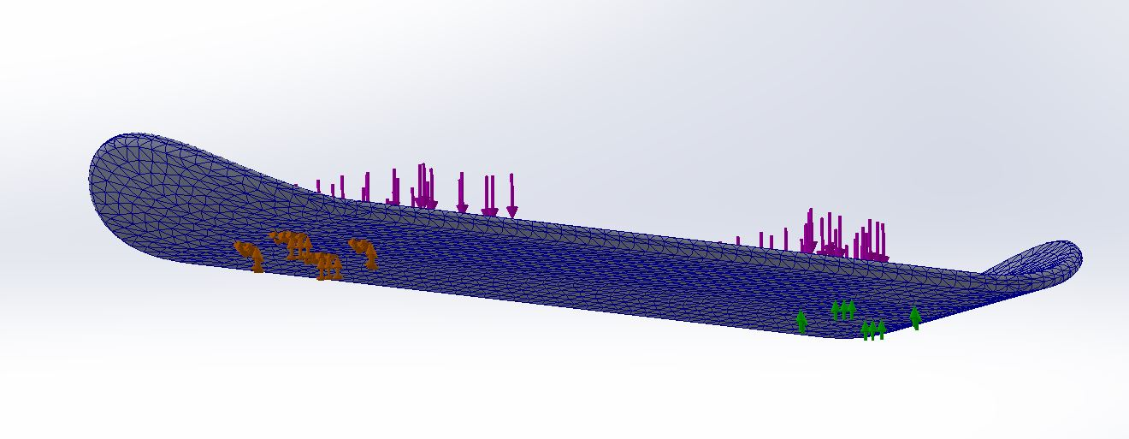

Figure 6. (Top) Applied Fixtures, (Middle) Applied Forces, (Bottom) Fully defined FEA model
Results
Upon calculating stress, displacement, and mass properties for the three different materials all using a model that was 12 mm thick, it was possible to deduce which material would be most viable to further optimize by varying the thickness of the board. A table summary can be seen below, with the full FEA analysis plots in Appendix A.

 | Maximum applied Stress | Yield Strength | Factor of Safety | Displacement | Mass
American Red Maple Wood | 3.185*10^6 Pa | 2.830*10^7 Pa | 8.85 | 9.981*10^-2 mm | 873.72 g
6061 Aluminum | 2.997*10^6 Pa | 5.515*10^7 Pa | 18.4 | 1.276*10^-2 mm | 4814.4 g
High-Density Polyethylene | 2.929*10^6 Pa | 4.3*10^7 Pa | 14.68 | 7.678*10^-1 mm | 1697.52 g

Design Optimization
Since all materials were well within the given constraints and objectives, each material could be a viable option. However, the American Red Maple Wood had ample headroom for optimization while being significantly lighter than the other materials, making it the best candidate for further analysis.

Conclusion
By reducing the thickness of the deck to a mere 10mm, a maximum displacement of 0.1638 mm (6.45*10^-3 in.) was calculated, which is significantly less than the 0.375 in. high bound of displacement. The safety factor for this thickness was 6.5, also making it safer than the minimum requirement of a safety factor of 3. This means that the deck could’ve been optimized (i.e. thinned) even further, but this is where a disconnect between computational analysis and real-world usage begins. Even though the idealized material could become thinner, making a skateboard deck less than 1 cm thick could result in very sharp edges, making them potentially hazardous when a rider falls and lands on their skateboard. Thus, the physical, intuitive boundary of the thinnest deck will be maintained at 10 mm, with a final deck weight of 726.81 grams.

Appendix A.

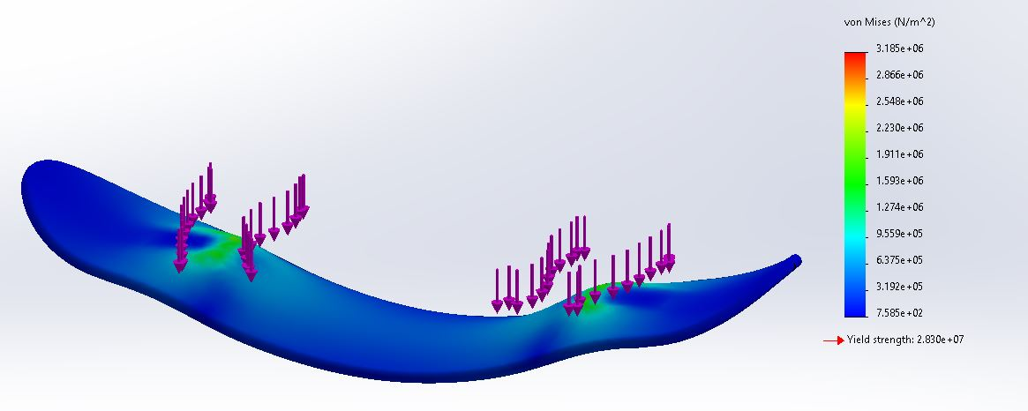

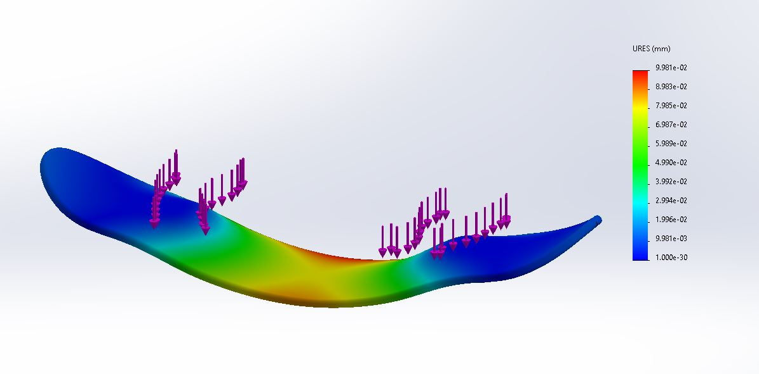

FEA Analysis of American Red Maple Wood (Von misses Stress & maximum displacement)

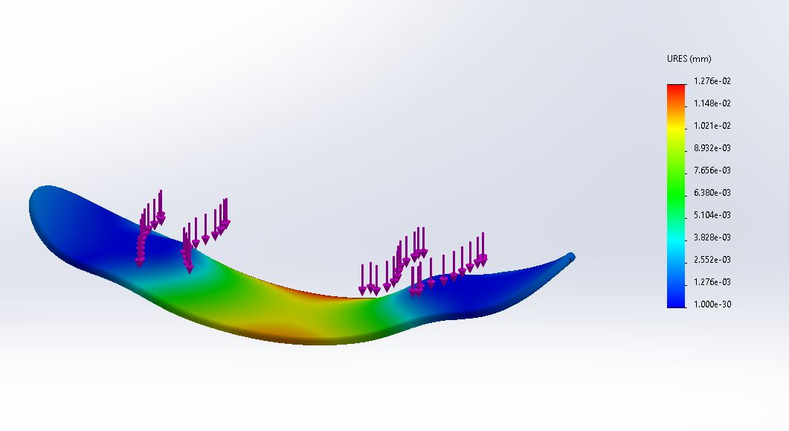
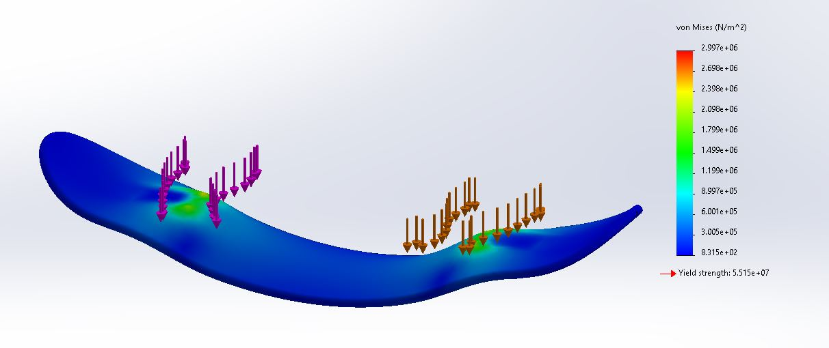

FEA Analysis of 6061 Aluminum (Von misses Stress & maximum displacement)

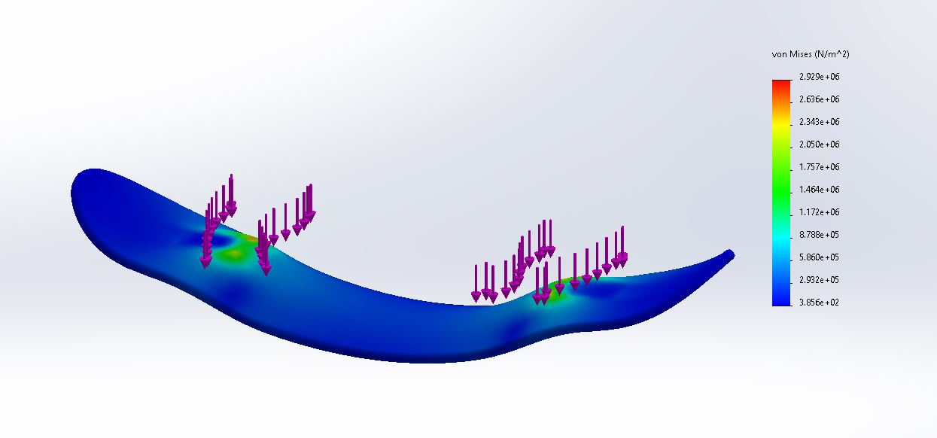
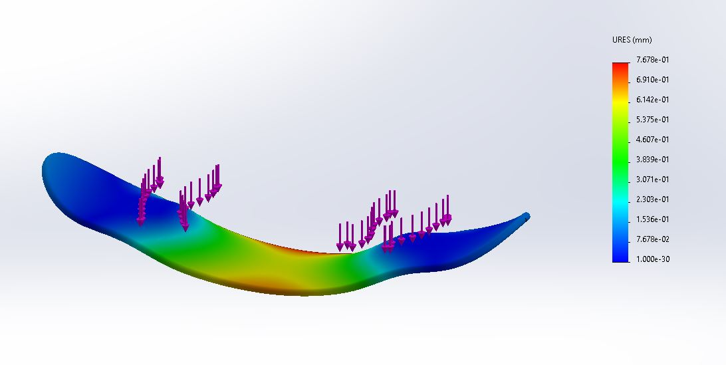

FEA Analysis of High-Density Polyethylene (Von misses Stress & maximum displacement)

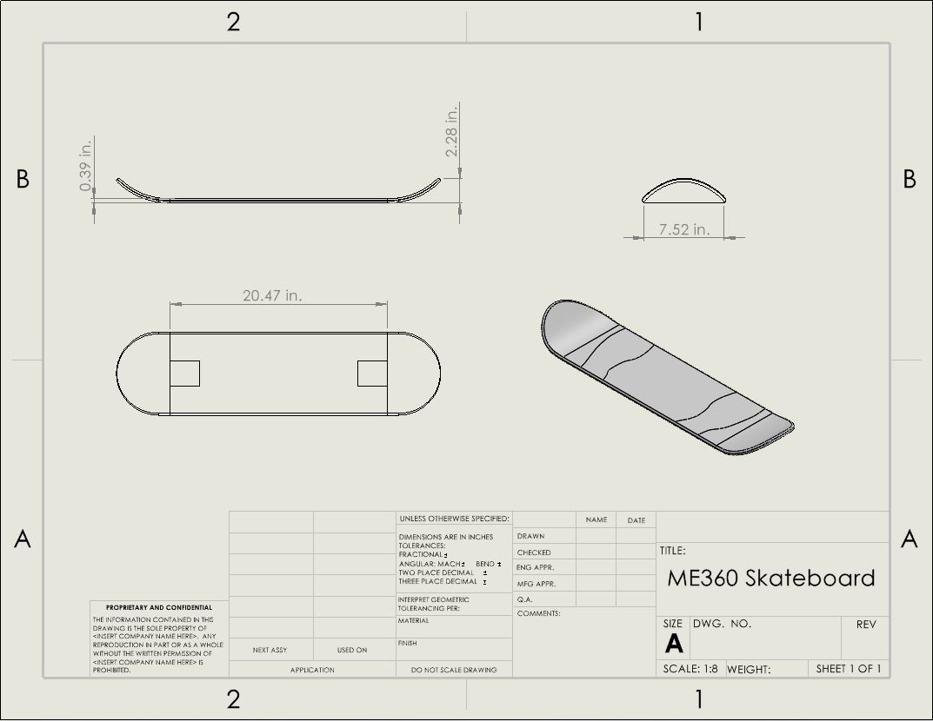
Final engineering drawing of dimensioned skateboard deck

Citations
https://skateboardgeek.com/best-skateboard-decks/

https://matweb.com/search/datasheet_print.aspx?matguid=67e57f907bc842259e268a5c8e4a7457

